Bot Net Rules

Bot Net is a strategy game with the goal being to capture all the corners of the board.
This can be done by rolling the Dice, Using cards And infecting other teams Networks.

“How to play”
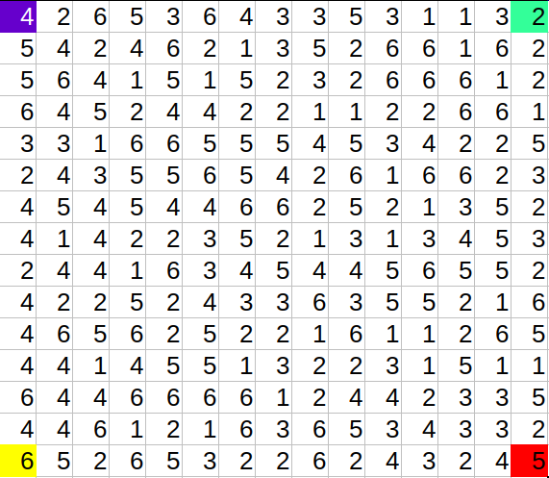
Players start on Each corner of the 15x15 game board, player 1 being blue, player 2 being red, player 3 being green and player 4 being yellow. Players can use any method they would like to figure out the order that they play. The first Person to go first rolls the dice and the number shown on the dice is the amount of “points” the player has to spend on his/her bot net.
Players are allowed to add up or distribute there points . To capture a space players need to have the same amount of points or more points.
Example: player 1 rolls a 6
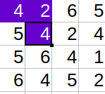
player one could capture spaces “2” and “4”
by doing the math 2+4=6 that would be all your
points then it would be the next players turn.
or player 1 could just capture space “5”
by doing the math 6-5=1 we have 1 point left which
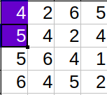
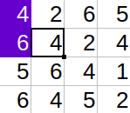
we could use to add some power to space “5” and do 5+1=6
then Space “5” is now “6” then we have no more points left
and its the next players turn.

“Cards”
cards are shuffled and put into a deck and are pulled every other turn.
Some cards in the deck and be held and used any time during the game.
When a card is used it is put in the bottom of the deck. Please be careful they are fragile and I really worked hard on this game so no folding them or Making them into airplanes.

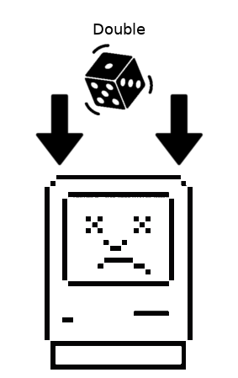
This card when Pulled Doubles The players Roll amount
can be Held by the player and played
any time during the game, Remember this card
must be Pulled BEFORE you roll

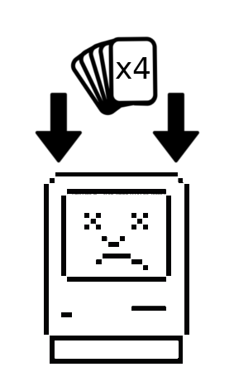
This card When pulled will
give the player a full hand of cards “4 cards”
This card can be held by the player and used
any time during the game. But MUST
be played BEFORE you roll.
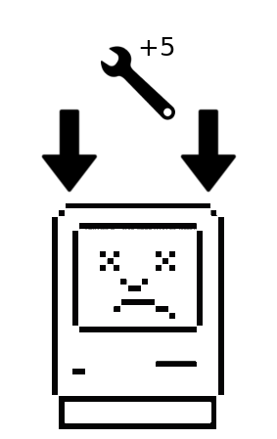
This card when Pulled Will give the player
“5pts” to disperse across his/her bot net. this can
be divided between multiple machines or used
on one machine, its the Players Decision.
This card MUST be used When pulled.
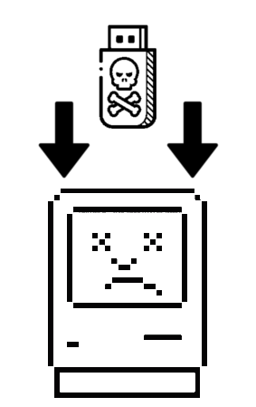
This card When pulled will allow the player to infect
any machine on the board. “Points Still apply” this can
be Held by the player Or be used when Pulled its The
Players Decision to make.
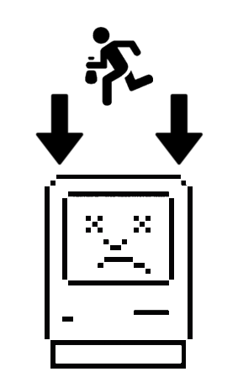
This card when pulled will allow the player to take ONE
card From anyone in the game. When pulled the player
tells the Player he/her wants to steal a card from that they
want one of there cards. Then the player with cards has to
shuffle there cards and show them face down and the Thief then picks one.
This can be Held and Used any time During the Game.
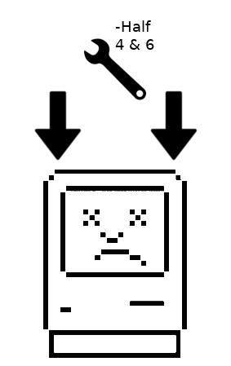
This card when pulled Will force the player
to take half off all Machines with the numbers “4 and 6” on His/Her bot net
and Change them to “2 and 3” this card Must be played When Pulled.

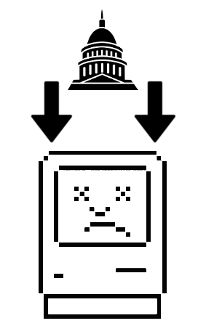
This card when Pulled will Force the player to
take 4 point away from all your Machines.
If a machine after taking away 4 points is a “0”
then the space is vacant and becomes a “1”

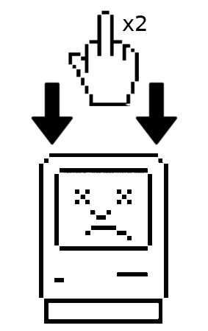
This card when Pulled allows the player
to roll twice in one turn. This card can be
held and used and used any time During the
game BEFORE a roll.

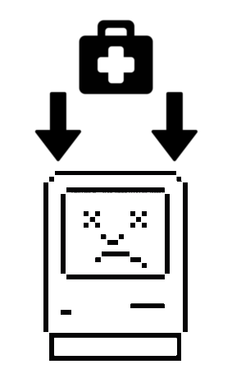
This card when Pulled allows the player
to Block any card in the deck. This card
can be Held and used any time During the game
AFTER a card has been played.

“Using your bot net to your advantage”
later in the game when everyone has rolled a few times
you can use a cool but risky trick. Lets say your player 1 and roll a “2” and you want to capture the “5” space you could take 3 away from your “6” from earlier and it would become a 3 and then you can add the 3 to your roll 3+2=5 and then capture the “5” space But remember you can only take a limit of 6 points out of your bot net a roll. If you remove all the points from a space
the space becomes Vacant and its value is replaced to a “1”

“Attacking”
this game would not be a game about bot nets without Infecting and making your bot net larger!
Players can attack and take over captured spaces the same way but you must have the same or more points to capture a space. Also if you capture a space and the direction your capturing has a string of the same number you can capture the whole line
Example:
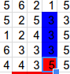
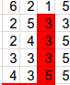
I am player 2 and I rolled a “4”
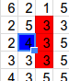
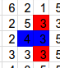
now I want to take the space “3” I can take “3” but I can also take the whole line of “3” because they are connected and are going the same direction

now lets say I am player 1 and I also roll
a “4” and I want to take the “3” space
I can only take ONE “3” space because they
are not lined up in the direction I am attacking.

Defending:
Players can re-range there points across there bot net
for a player to do this they have to replace this action with rolling the die that turn.

